**HOW TO’S**

**How to Scrape Dynamic Data through Excel?**

(Using Macros and VisualBasic)

*Aakrati Sahu*

*Information Security Consultant*

*Netmonastery NSPL Mumbai*

*Contact- aakratisahu5@gmail.com*

Step 1. Analyze the website code carefully.

1. The site I am using here records the weather in India.

<https://www.timeanddate.com/weather/india>

(It is just for the demonstration purpose, make sure to check policies for scraping any website).

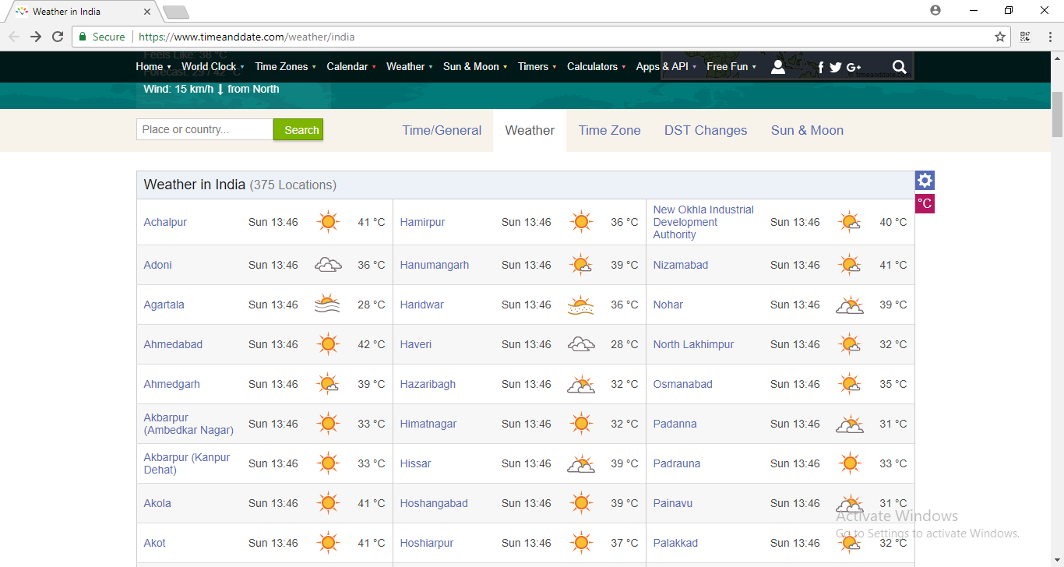

1. Inspect the source code of the data you want to capture.

Here in this case I am capturing this table so I will look for the codes behind this data.

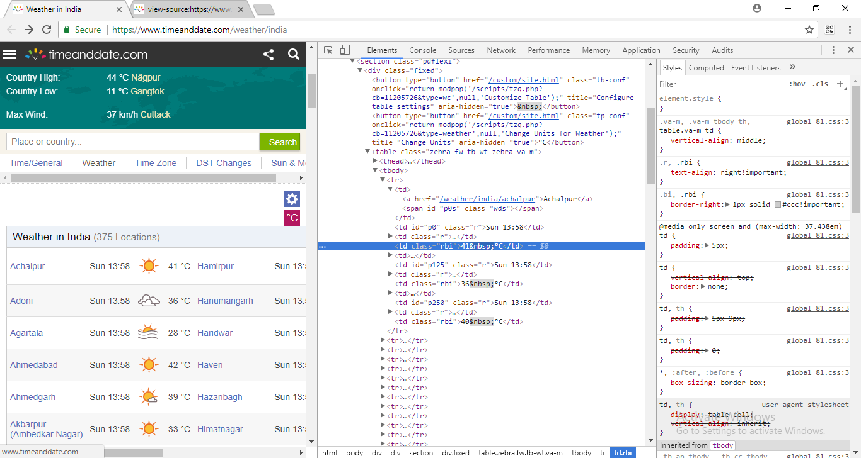

Step 2. Working on Macro.

1. Open Excel and go to “Record Macro” under “Developer” tab.

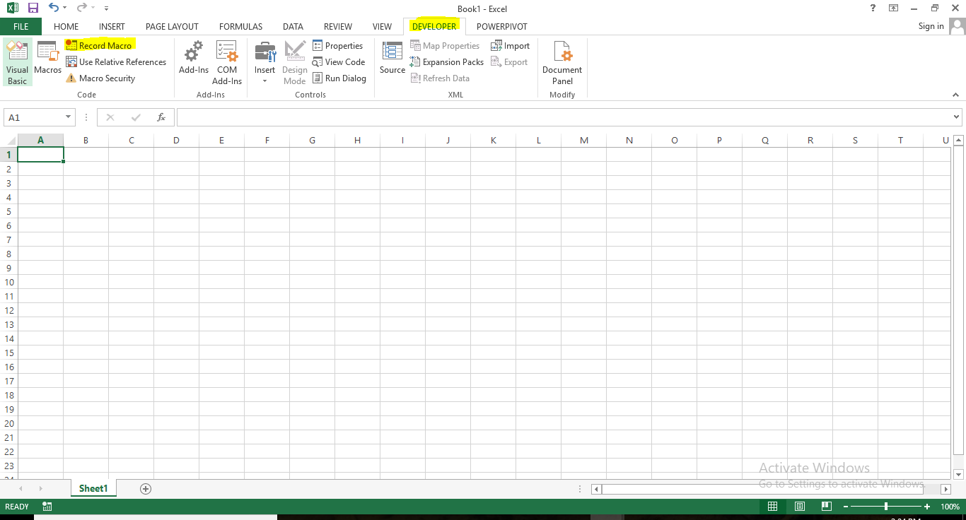

1. Start recording Macro

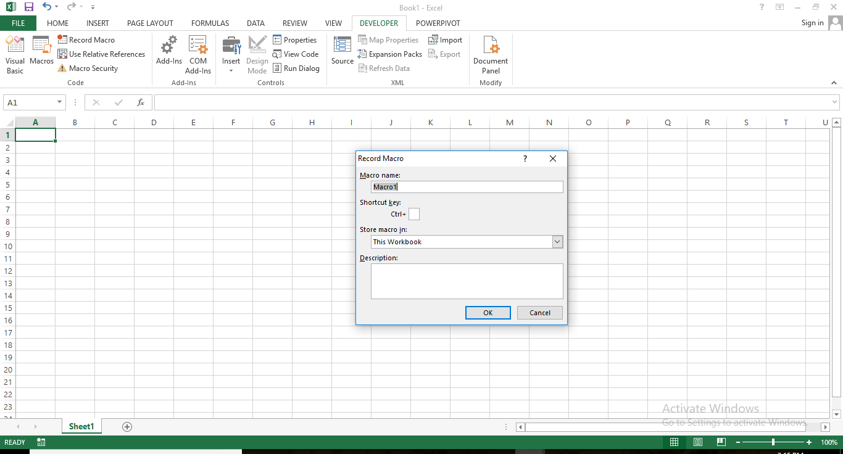

1. Go to “from web” under the “Data” tab.

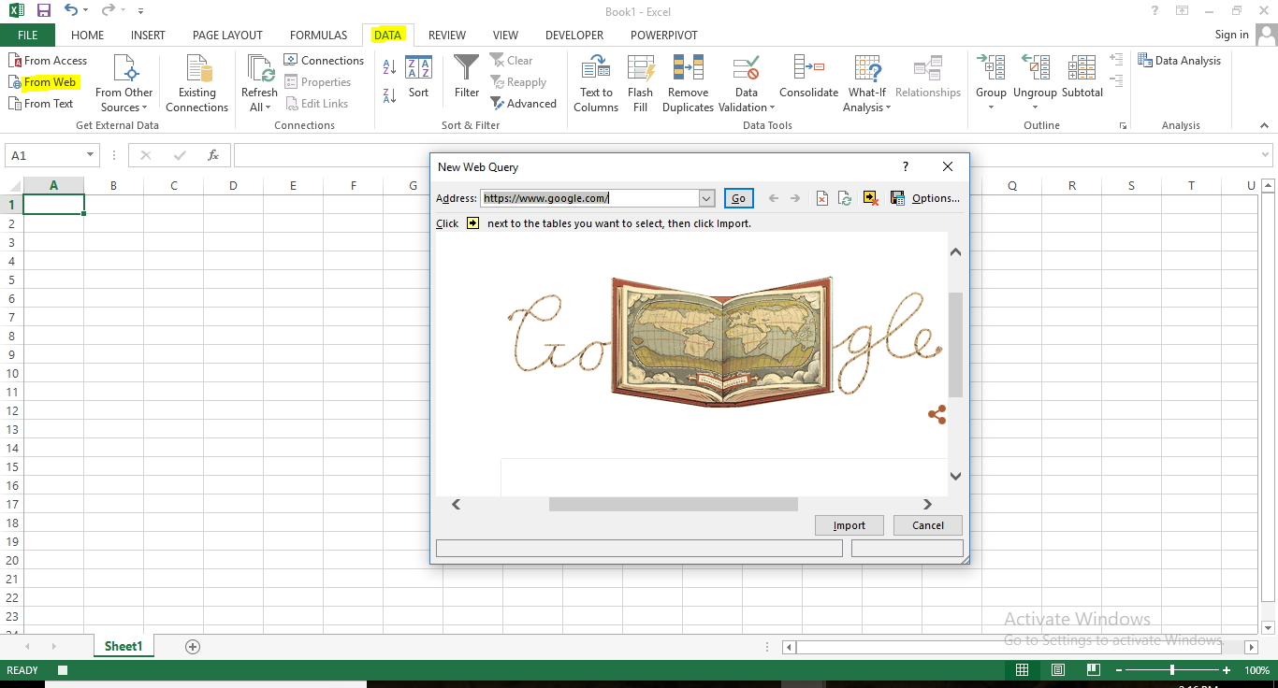

1. Enter address of the website you want to scrape in a “new web query” dialog box.

Note- You may get some error after pressing “Go”. Simply click “Yes”.

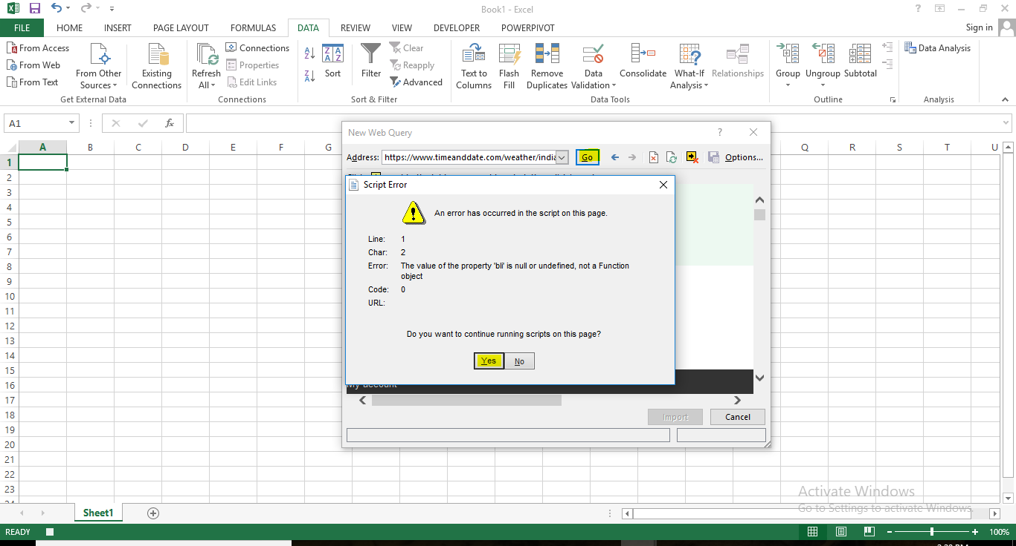

1. Select the table you want to scrape then import it.

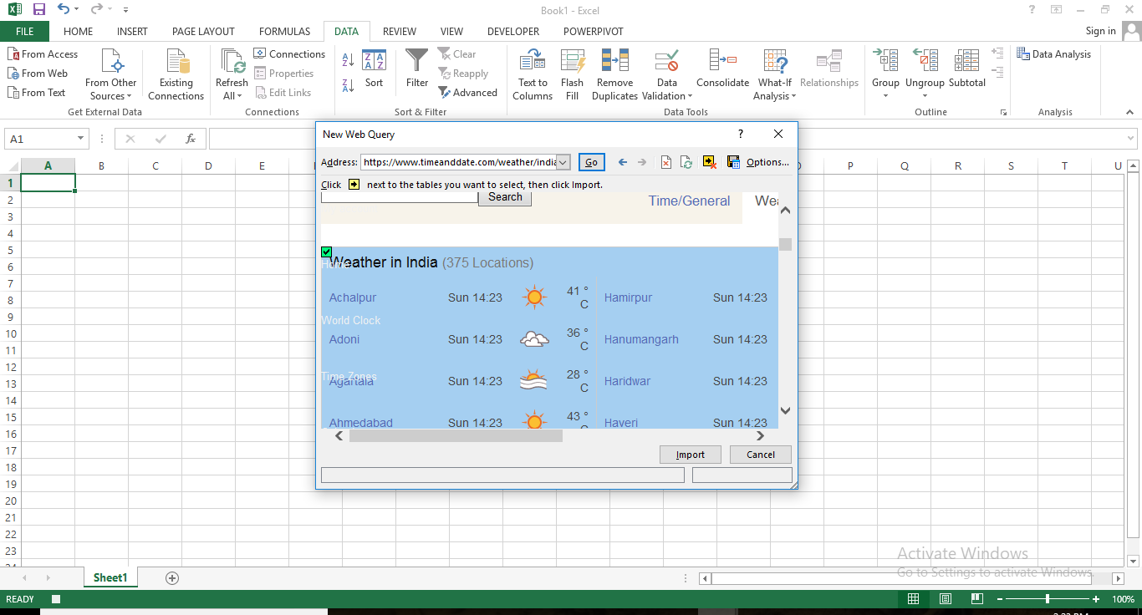

1. Name the sheet. (Here it is Temperature) 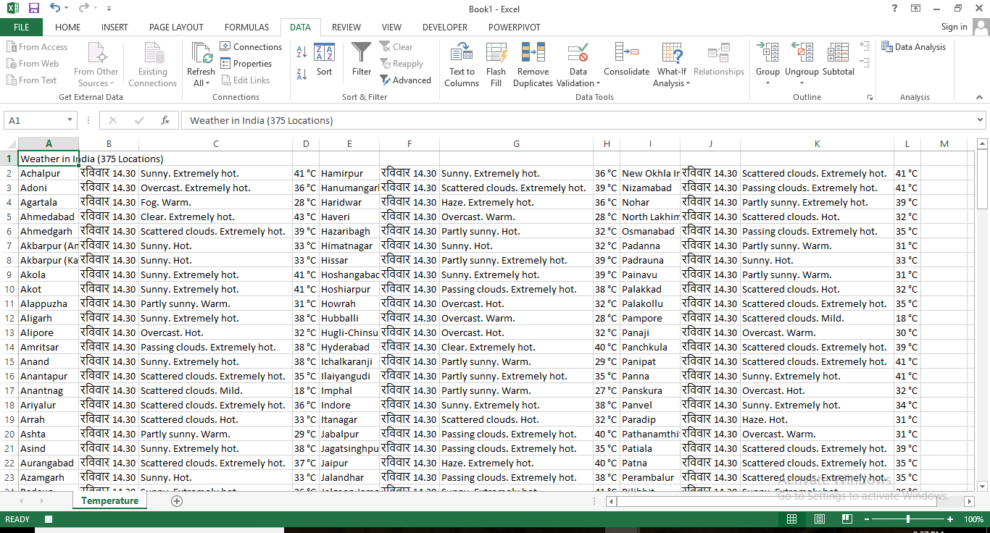
2. Now stop the Macro recording under “Developer” tab.
3. Go to Macros and choose the macro you have recorded.
4. Press “Edit”.

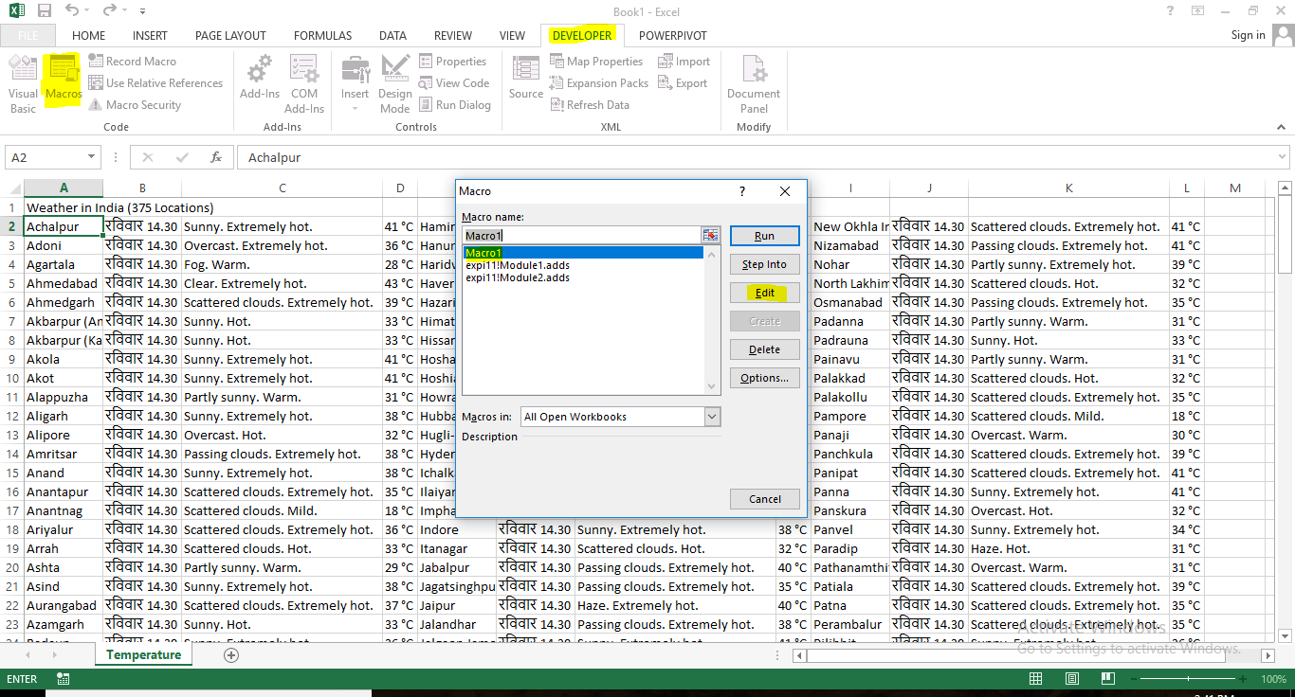

Step 3. Working on Visual Basic.

1. You can create a new module (go to insert and choose module) or edit the same.
2. Copy the highlighted code to a notepad file.

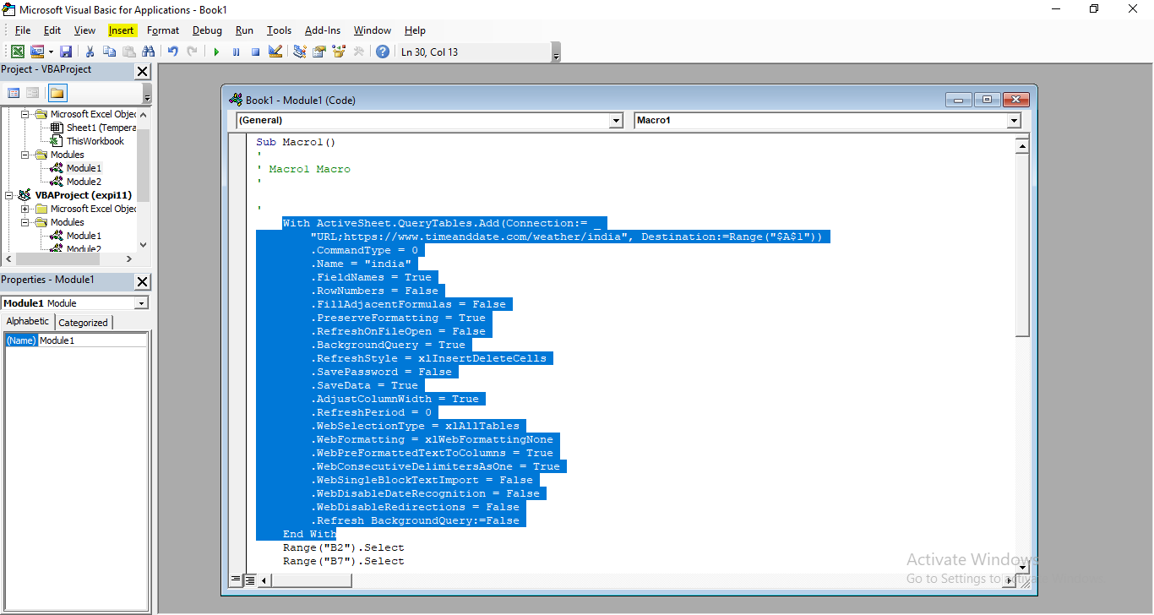

1. Change the existing code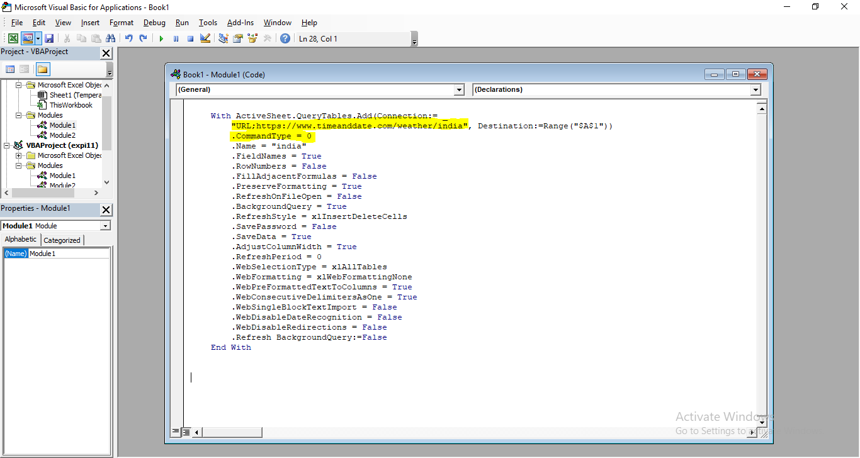
   1. Use “mystr” instead of the URL given.Put an apostrophe to remark the “ 'CommandType = 0 ”
2. Add the following code.

The below code will automate the process using a loop that creates

1. New worksheets
2. Automatically changes the link to the web pages that have the required data.

//

Sub adds()

For x = 1 To 5

Worksheets("Temperature").Select

Worksheets("Temperature").Activate

mystr = "URL;https://www.timeanddate.com/weather/india"

mystr = Cells(x, 1)

Worksheets.Add(After:=Worksheets(Worksheets.Count)).Name = x

//

#Note- Don’t forget to put the highlighted yellow code at the end.

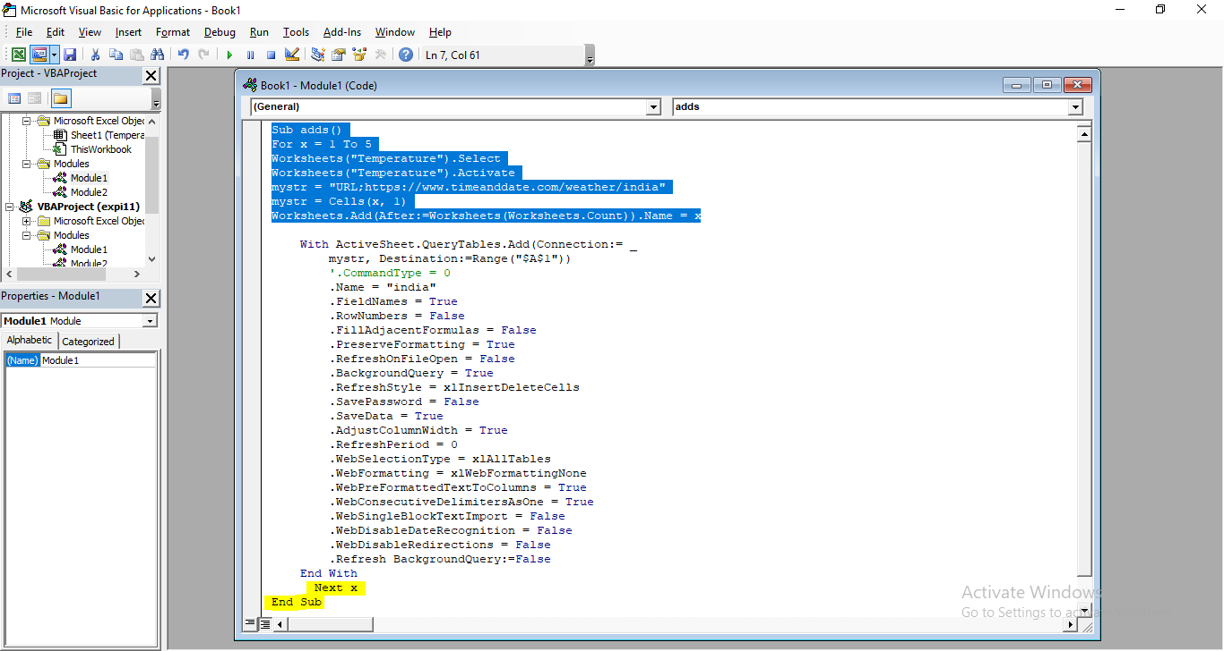

1. Make few changes in the sheet (Containing the links that get you the data from the appropriate web pages).

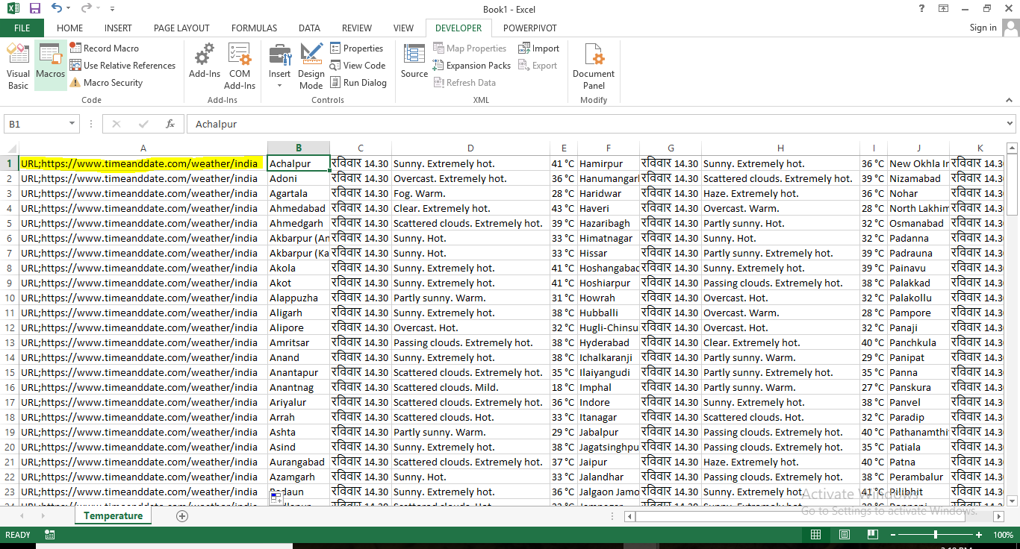

#Note- In this case, the same web page contains the data for every 375 locations. (As analyzed through page source code).

The same code will be useful for the sites that fetch data through various web pages. (For e.g. mobile comparison site that fetches price through various online marketplaces).

For that you just need to update the URL analyzed through page source code in the Excel sheet.

1. Hit the “run” button

Five sheets have been added.

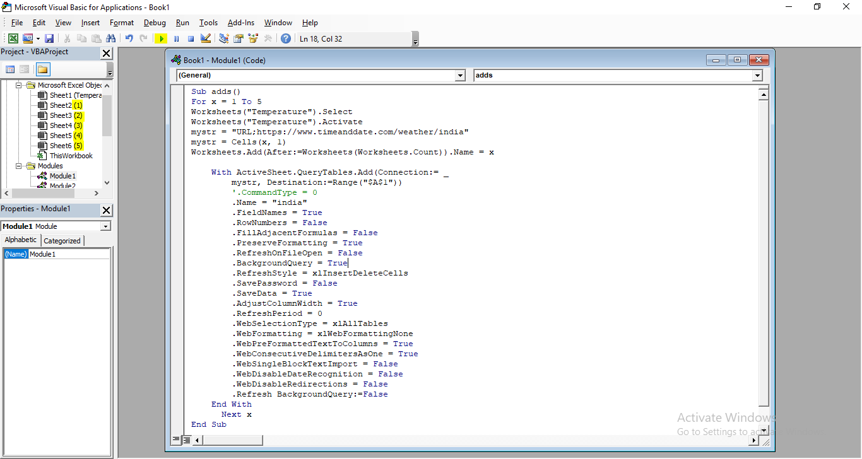

Step 4. Data is updated successfully.

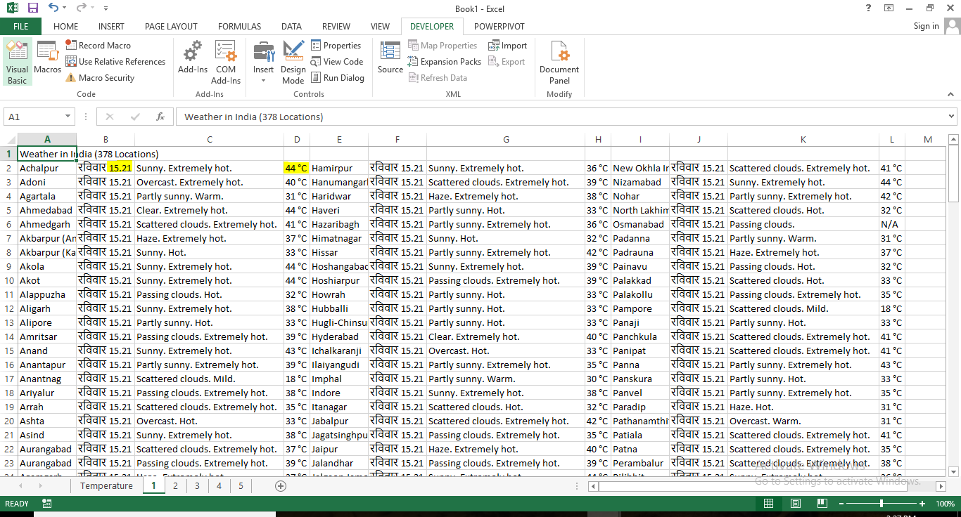

Step 5. Save the file.

Save the file as type “Excel Macro-Enabled Template”

